THE JEWISH HISTORICAL MUSEUM IN BELGRADE

The Federation of Jewish Communities of Serbia

Belgrade

2010.

Published by

The Federation of Jewish Communities of Serbia

Author

Vojislava Radovanovic

Photographs, scanning and digital processing

Veselin Milunovic

Serbian Editing

Jasmina Ognjenovic

English translation

Zaneta Miljanic

Assistance in information related to World War Two

Jovan Mirkovic

Print layout

Dusan Oluic

Printing house

KOSMOS

Circulation

750

Printing of this publication was supported by

The Assembly of the City of Belgrade – Secretariat for Culture

CIP - Ʉɚɬɚɥɨɝɢɡɚɰɢʁɚ ɭ ɩɭɛɥɢɤɚɰɢʁɢ

ɇɚɪɨɞɧɚ ɛɢɛɥɢɨɬɟɤɚ ɋɪɛɢʁɟ, Ȼɟɨɝɪɚɞ

069.02:94(=411.16)(497.11)(036)

ɊȺȾɈȼȺɇɈȼɂȶ, ȼɨʁɢɫɥɚɜɚ, 1960-

ȳɟɜɪɟʁɫɤɢ ɢɫɬɨɪɢʁɫɤɢ ɦɭɡɟʁ ɭ Ȼɟɨɝɪɚɞɭ / [ɚɭɬɨɪ ȼɨʁɢɫɥɚɜɚ Ɋɚɞɨɜɚɧɨɜɢʄ ;

ɩɪɟɜɨɞɢɥɚɰ ɧɚ ɟɧɝɥɟɫɤɢ ʁɟɡɢɤ ɀɚɧɟɬɚ Ɇɢʂɚɧɢʄ]. - Ȼɟɨɝɪɚɞ :
#ɋɚɜɟɡ ʁɟɜɪɟʁɫɤɢɯ ɨɩɲɬɢɧɚ ɋɪɛɢʁɟ, #ȳɟɜɪɟʁɫɤɢ ɢɫɬɨɪɢʁɫɤɢ ɦɭɡɟʁ, 2010 (Ȼɟɨɝɪɚɞ : Ʉɨɫɦɨɫ). - 28, 29 ɫɬɪ. : ɢɥɭɫɬɪ. ; 24 cm

ɇɚɫɥ. ɫɬɪ. ɩɪɢɲɬɚɦɩɚɧɨɝ ɩɪɟɜɨɞɚ: The Jewish Historical Museum in Belgrade. - Ɉɛɚ ɪɚɞɚ ɲɬɚɦɩɚɧɚ ɭ ɦɟɻɭɫɨɛɧɨ ɨɛɪɧɭɬɢɦ ɫɦɟɪɨɜɢɦɚ. - ɉɨɞɚɬɚɤ ɨ ɚɭɬɨɪɤɢ ɩɪɟɭɡɟɬ ɢɡ ɤɨɥɨɮɨɧɚ. - Ɍɢɪɚɠ 750.

ISBN 978-86-88113-01-4

a) ȳɟɜɪɟʁɫɤɢ ɢɫɬɨɪɢʁɫɤɢ ɦɭɡɟʁ (Ȼɟɨɝɪɚɞ) – ȼɨɞɢɱɢ COBISS.SR-ID 175964940

The Federation of Jewish Communities of Serbia | 5

Introduction

The Jewish Historical Museum (JHM) in Belgrade is a comprehensive and, in many ways, unique museum in Serbia. It is the only Jewish museum in the country, thematically special-ized, and very complex in terms of contents. Apart from museum exhibits, the Jewish Histor-ical Museum also has its own, relatively large, archives whose documentation and photo-documentation are a testimony both of the Holocaust, during which many Jewish communi-ties literally perished, and of the life and activities of Jewish communities from Serbia and the whole territory of former Yugoslavia during the 19th and, even more, the 20th century, including the present times.

The Jewish Historical Museum was founded in 1948, as part of the Federation of Jewish Communities of Yugoslavia. It is interesting to note that the idea of founding a museum of this type dates much further back. Already after the First Congress of the Federation of Jew-ish Religious Communities of the Kingdom of Serbs, Croats and Slovenes, held in 1921 in Za-greb, there were recommendations and plans concerning the foundation of such a museum as the right place to preserve the heritage and cultural identity. Yet, the idea had not mate-rialized. Having in mind the World War II and the events that followed from 1941 in Yu-goslavia, from this time perspective one could say that it is in fact a lucky coincidence that the Jewish museum had not been founded at that time.

After the Federation managed to revive itself as the leading institution of the surviving Jewish communities of the liberated Republic of Yugoslavia, in autumn of 1945, it invited its members to collect all data available about the Holocaust and the participation of Jews in the National Liberation Movement. This was the first and very specific step towards found-ing a museum. Relatively soon afterwards, the Museum – Historical Department was estab-lished in Zagreb within the Legal Division of the Federation. Systematic efforts to identify and preserve the archives began. In 1952 all the archives collected until that time were moved to Belgrade, and the search and collection efforts continued. The “Department” was beginning to develop towards a full museum institution. The same year, 1952, an exhibition was organ-ized on the occasion of launching the impressive monument by artist Bogdan Bogdanovic at the Sephardic cemetery in Belgrade, dedicated to the Jewish victims of the Holocaust. On the occasion of commemorating the tenth anniversary of its revival, in 1955, the Federation staged another exhibition on the topic of activities of the whole Jewish community in the then Yugoslavia.

During that period, the Federation, as the founder and owner of the Museum, was in per-manent contact with all the member Jewish communities that were revitalized after the un-precedented persecution during the period 1941 - 1945. The Museum continued to receive

6 THE JEWISH HISTORICAL MUSEUM

materials relevant to the history of Yugoslav Jews. The individual, surviving Jews also responded to the invitation of the Museum and contributed individual exhibits and family photographs, and there were contributions from collectioners whose collections were hidden and preserved, and others as well. Many of them made legacies to the Museum containing artifacts from their families and homes, and these legacies possessed historical, ethnological and artistic value; also depending on its resources available the Museum on occasions also purchased exhibits. From its very establishment, until the year 1959, the Museum had managed to collect sufficient museum and archive materials to establish that same year a good and picturesque permanent museum exhibition. On 19 May 1960, the Museum of the Federation of Jewish Communities of Yugoslavia was opened to the public, in the same building which presently houses the Federation. Soon afterwards, the name of the Museum was changed to The Jew-ish Historical Museum (JHM), which is much better suited to its purpose and content. The collection and professional processing of collected materials continued, so that in 1969 the second permanent exhibi-tion of the Jewish Historical Museum, much richer and more expressive, was presented. The credit for its concept goes to Vidosava Nedomacki, Ph.D., the first Museum Manager.

After the disintegration of Yugoslavia in 1992, The Federation of Jewish Communities of Serbia was established, consisting of ten Jewish communities, which is the total existing in our country. The status of the Jewish Historical Museum remained unchanged – it is an integral part of the Federation of Jew-ish Communities of Serbia. Although existing within the framework of the Federation, the Museum de-veloped into an institution of its own right, living its own specific life, its professional team and busi-ness contacts with other museums.

Since the permanent exhibition of the Museum was opened long before the disintegration of Yu-goslavia, it deals with the historical, ethnological and general cultural topics relevant to the Jewery of the overall then Yugoslav region. Due to the grave political and economic difficulties which, beginning in 1992, overwhelmed our country, Serbia, it has not yet been possible to develop a new, differently de-signed museum exhibition. However, having in mind the fact that the Jews from this part of the Balka-ns have had a common history and cultural features – it is unavoidable that the concept of such a new exhibition should maintain, at least partially, a more comprehensive approach to such a presentation which will develop in the future. For all of these reasons, and thanks to the complex and subtly de-signed concept, the actual age of the permanent exhibition of the Jewish Historical Museum does not bother anyone, as it does not have impact on the excellent quality of information regarding Jewish his-tory of way of life.

The Federation of Jewish Communities of Serbia | 7

Permanent Exhibition of the Jewish Historical Museum

In its form, the permanent exhibition is very much as a journey through time – along the historical and ethnological corridors along which in chronological and thematic manner the main aspects of Jewish history, culture and the way of life in the territory of former Yugoslav republics appear.

The introduction to the story begins with a map of former Yugoslavia, in which the mi-grations of the Jewish population are plotted, indicating the places where they lived, start-ing with Roman times at the beginning of the new era until the first half of the 20th centu-ry, and also after World War II.
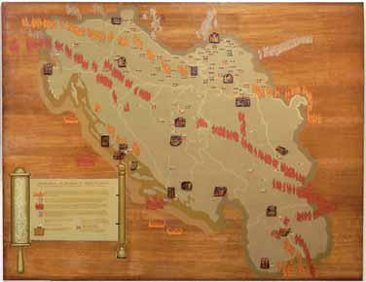

Symbols and figures in yellow color:
Romanoittes, Jews who lived scattered in provinces of the huge Roman Empire, started to settle at the begin-ning of the new era. Ac-cording to archeologi-cal findings, the oldest Jewish settlements in this part of the Balkans, were established in Sto-bi in Macedonia, and along the Adriatic coast.

8 | THE JEWISH HISTORICAL MUSEUM

Symbols and figures in white color:

Ashkenasi Jews, Jews from central and eastern Europe, settled the former Yugoslav territory over a long period of time, from the 12th to the 20th century. Numerous groups migrated for economic rea-sons, but even more fled from persecution and pogroms that they were exposed to, especially in Poland and Russia during the 18th and 19th centuries. They settled across the western Balkans, but were most-ly concentrated in northern Serbia – in Vojvodina, and also in Croatia and Slovenia.
Symbols and figures in red color:

Sephardic Jews, Jews from the Iberian Peninsula, by force of the edict of the royal couple Isabel and Ferdinand and under the influence of the Inquisition, were expelled from Spain in 1492, and from Portugal in 1498. They scattered across Europe, northern Africa and the Near East. A very large num-ber of Jews settled in Serbia, Bosnia, and Macedonia, which were at that time under the rule of the Ot-toman Empire. The Ottoman rulers were benevolent towards the Sephardic Jews, perceiving them as excellent traders, craftsmen, and civilized pacifists, who can only be of benefit to any country.
Until the beginning of the World War II in 1941, the number of Jews living in former Yugoslavia was about 80,000 – 82,000. Of that number, about 35,000 – 37,000 Jews lived in Serbia, divided in Sephardic (yellow boxes with figures) and Ashkenasi Jewish communities (brown boxes). The number of Orthodox Jews was negligible, consisting only of a small number of communities in Vojvodina (dark brown boxes).
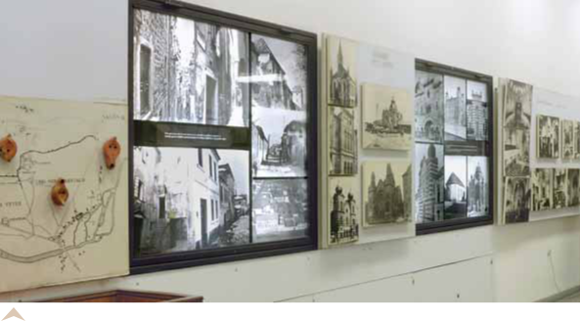

After the introductory exhibits, the museum takes us through the Jewish quarters, streets, ghettos, Jewish cemeteries, and synagogues in different towns of former Yugoslavia.

In countries under the Ottoman dominance, in Serbia, Bosnia, and Macedonia, ghettos never exist-ed. Jews, just like the other urban population, lived in streets called “mahala” (city quarter, Turkish word), which were not clearly delineated from other town quarters. Ghettos, as parts of town with cer-tain definite features (exclusively Jewish, with iron gates separating the quarter from the others) were characteristic of Croatia, including Dalmatia, and Slovenia.

The Federation of Jewish Communities of Serbia | 9

The Jewish quarter in Bel-grade was in Dorcol neighbor-hood, although Jews also lived in other parts of town. There are no documents preserved, but in-direct data indicate that the Sephardic community was es-tablished in the 1520’s, while the Ashkenasi community al-ready existed at that time. There were not many Ashkenasi Jews, and they were settled mostly on the Sava river hill. It is also be-lieved, with a great degree of certainty, that the old syna-gogue in Dorcol, which for a long time served the needs of both the Sephardic and Ashke-nasi Jews, was build in the first half of the 18th century, and the
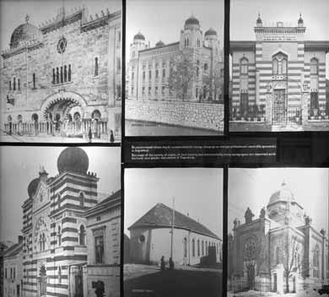
older and the first synagogue was built in the first half of the 17th century, later to be destroyed. The old synagogue was reconstructed several times and it existed as long as 1952, when it was finally pulled down. The Great Jewish synagogue, Beit Jisrael, was built in 1908, in another part of the same land plot in which back in 1928 when the construction began of the impressive building of the Sephardic community, which still exists today. The Sephardic synagogue was destroyed during the Ger-man bombing of Belgrade during WWII. Presently, there is just one, Ashkenasi, synagogue in Belgrade, Sukat Shalom, built in 1925 in the then Kosmajska Street (the part closer to the Sava downhill). This synagogue is actively used, with regular religious services.
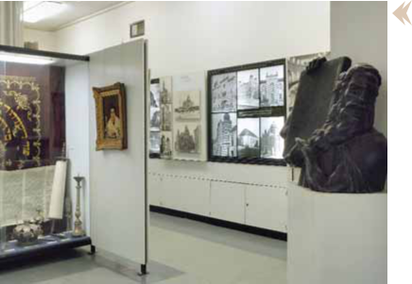

The next along the way is the sculpture of Moses, by sculptor Slavko Bril, Moses “wakeful” over the separate area dedicated to the collection Judaica – a specific ethnological collec-tion with elements of applies art, consisting of synagogue ritual objects, objects for home holiday rituals, clothes, amulets, and other original exhibits illustrating the Jewish tradition, religion and culture based on scrolls of the holy book Torah – the
Five Books of Moses.

10 THE JEWISH HISTORICAL MUSEUM
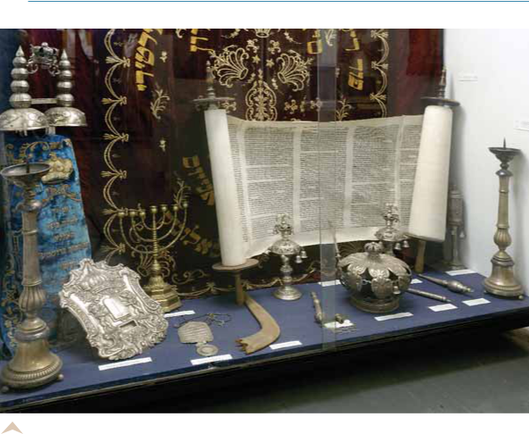

On the right, an opened Torah, with bookmarks – jadaim (pl. Hebr.); on the left, a closed Torah with equipment consisting of: cloth cover – meil, two decorations for Torah holders - Rimon-im (pl. Hebr.) on top, between which is a small stylized Keter Torah (Torah crown, Hebr.), while in front is the Torah shield. Behind the said exhibits is a synagogue curtain – Parochet (Hebr.), used to cover the holy cupboard – Aron Hakodesh (Hebr.), in which Torah and accessories are preserved when not in use. There is a also a special smaller Torah shield, a menorah, a ritual horn used to an-nounce holidays – shofar (Hebr.), a larger Keter Torah, several Rimonim and Jadaim, and two large synagogue candelabrums. These exhibits originate from Austria-Hungary, eastern Europe, Bosnia and Thessalonica, from the period 19th and 20th century.

As we continue, we move on to other selected pieces of original ritual objects from the Judaica collection of the JHM.
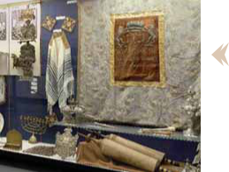

Parochet from the 18th / 19th century, in front of which are exhibited Jadaim, Rimonim, Keter Torah and Torah shield, with prayer schawls on each side – tal-lit (Hebr.) made of different materials, one of silk, one of wool. These objects originate from the countries of the Aus-tria-Hungary, eastern Europe, and Israel; period 19th – 20th century. In the lower part of the cupboard with exhibits is a

special exhibit – the Torah from Livorno, 18th century.

The Federation of Jewish Communities of Serbia | 11

On the left, on a vertical line are the nine-branched candelabrums – Hanukia, different in shape and form but all used for the same purpose: for the Hanukkah, the Festival of Lights, celebrating the victo-rious war waged by Jews against the ancient Greeks in liberating Judea in the 2nd century B.C. These rit-ual candelabrums originate from Austria-Hungary, Poland, the Netherlands; period 18th – 19th century.

Several objects used for Pessach – the High Holiday celebrating the exodus of Jews from slavery in Egypt under the leadership of Moses in 13th century B.C., their wander-ing through the desert and the final arrival into the land of Canaan (the territory of present-day Israel): different types of Pessach dishes and specially sewn covers for ritual un-leavened bread – Matsah (Hebr.) These objects originate from Poland, Romania, and Paris; period 19th – 20th centu-ry. The use of these objects is just a small portion of the com-plex rituals related to celebration of Pessach.
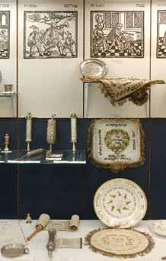
On the left are the selected ritual objects consisting of Megillah Esther (The Story of Esther, Hebr.), scrolls in silver or wood, of different dimensions and with different ornaments, the reading of which is the central part of the celebration of Purim – the holiday celebrating Esther who saved the Jews from pogrom during the Persian domination (6th – 4th century, B.C.). These objects originate from Italy and other countries of western Europe, the countries of the Austria-Hungary, eastern Europe and the Near East (Bagdad); period 17th – 19th century.

Objects used for Shabbath – the most significant Jew-ish holiday, celebrated from the sunset on Friday to the sunset on Saturday: up: one pair of candlestick holders, cups, glasses, plates and the Shabbath knife; down: cover used for Shabbath bread, challah, a plate, a candle-holder, dish for the Havdalah ritual (the ritual ending the Shabbath); to the right, up: selected specimen of small spice boxes – Besamim (Hebr.), also used in the rituals ending the Shabbath. These objects originate from the towns of Senta, Vienna, Graz, Bu-dapest, and generally from the countries of the Austria-Hun-gary, eastern Europe and Israel; period 19th – 20th century. To the very left of the display cupboard are the selected ritual objects used in certain segments of the life cycle: up: glasses and cups for weddings, prayer-book frames; down: Tallit Katan (Hebr.) – prayer shawls for baby boys, tools used for the circumcision, and a pitcher for ritual washing of hands. These objects originate from Vienna, Osijek, the countries of the Austria-Hungary, eastern Europe, Italy and
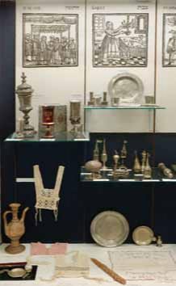
Serbia; period 19th – 20th century.

12 | THE JEWISH HISTORICAL MUSEUM
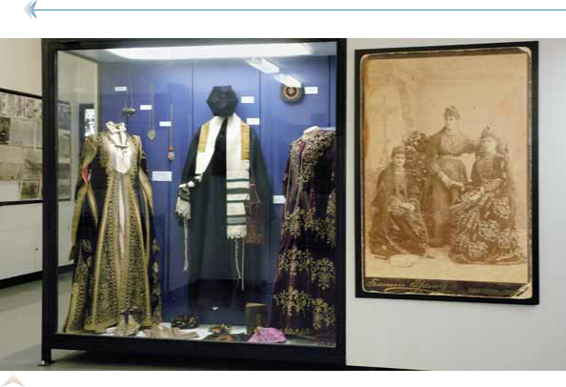

Specimen of clothing used by Sephardic women, rabbis and selected amulets. In the cupboard to the left are specific clothing items used by women - anterija, underneath is a cotton shirt, around the neck an amulet in form of a conspicuous necklace; down is a pair of women’s elegant embroidered shoes, an embroidered fermen jacket, and a women’s hat tokado (“tukadu”), to the right is an ele-gant velvet dress. The embroidery is done by gilded copper threads. In the middle is a rabbi robe. The cupboard also displays several skullcaps - kipa, handbags for prayer objects, several amulets and a prayer book printed in Vienna. The exhibits originate from Bosnia, Bulgaria, north Africa, and Israel; pe-riod 19th – 20th century.

The Jews lived in the Balkans continually throughout the Middle Ages, although due to uneven mi-gration trends and settlement very little has remained as traces of their living there. However, since the 14th century, we find written evidence
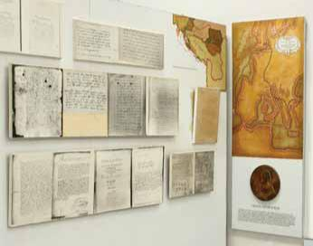
and sources about the Jewish popula-tion in Middle Age Serbian countries, as well as in the Dubrovnik Republic and major Dalmatian towns, such as Zadar and Split.

Copies of manuscripts from late Middle Ages and, in continuation, the beginning of the New Age present-ing the destiny of a Sephardic Jewess, Gracia Mendes Nasi, who fled Portugal, via Dubrovnik, to go to Turkey.

The Federation of Jewish Communities of Serbia ₁₃
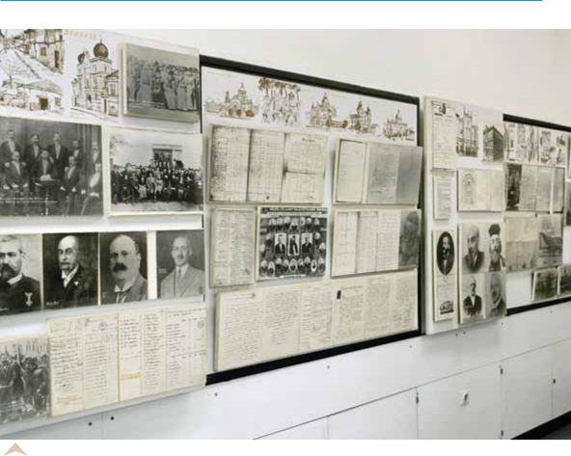

We move along this historical corridor and arrive to the 19th century, through the Jewish communities of Serbia, Croatia, and Bosnia. Copies of parts of different publications or records main-tained by Jewish communities in big and small towns, records, correspondence, lists, documents, sketches and drawings, reproductions of photographs of Jewish organizations, members of communi-ty management, rabbis, citizens, illustrating the way of life and organizations of Jewish communities during the 19th and at the beginning of the 20th century.
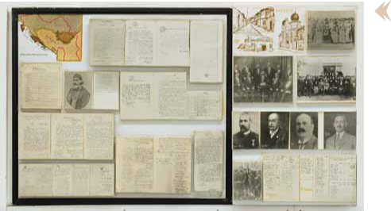

On the left panel is Serbia during the times of Prince Milos Obren-ovic; a map of Ser-bia and copies of documents. In the lower corner on the right is the “Com-munication by the Ministry of Justice” from the year 1884, with respect to the decision of the

14 THE JEWISH HISTORICAL MUSEUM

Berlin Congress held in 1878, whereby the Kingdom of Serbia is given independence, giving all of its citizens equal rights, irrespective of national and religious background.

The panel to the right contains reproductions of old archive photographs and copies of documents relevant to the life and activities of Sephardic and Ashkenasi Jewish communities in Belgrade during the 19th century and the first half of the 20th century: The Society of Jewish Women, established in 1875, at the celebration of its 25th anniversary in the year 1900; lists of Sephardic and Ashkenasi Jews in Belgrade in the year 1856; members of the management of the Sephardic community in 1889, and community photograph after the end of the World War One in 1918; several prominent Belgrade Jews; King of Serbia Petar I Karadjordjevic laying the foundation stone for the construction of the Sephardic synagogue Beit Jisrael in 1908.
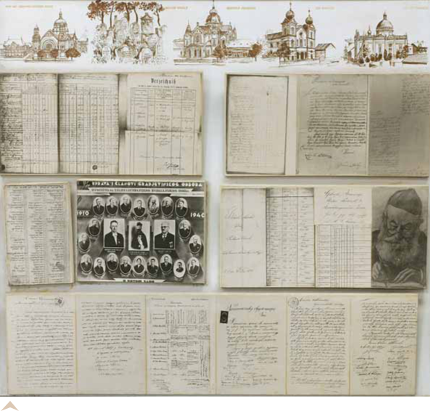

Reproductions of old archive photographs and copies of documents relevant to the life and ac-tivities of Jewish communities in different towns in Vojvodina – Novi Sad, Subotica, Ada, Zrenjanin, during the 19th and the first half of the 20th century.

The Federation of Jewish Communities of Serbia | 15
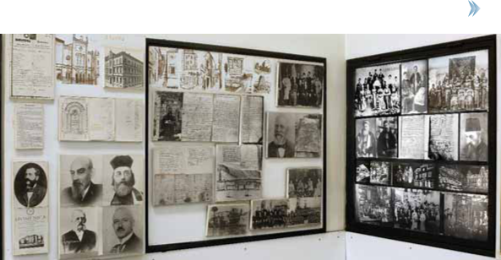

Reproductions of old archive photographs and copies of documents relevant to the life and ac-tivities of Jewish communities in Croatia – in Zagreb and in major Dalmatian towns, during the 19th and the first half of the 20th century, as well as a special photo-assortments dedicated to the Jews of Sarajevo, during the 19th and the beginning of the 20th century (the panel to the right).

Having in mind the type of this Museum, the permanent exhibition of the Jewish Historical Museum provides the visitor with historical and ethnological information about Jews in Serbia and former Yu-goslavia. Works of art – paintings and sculptures, are exhibited sporadically, and they belong to differ-ent periods and styles. The purpose of these carefully selected paintings and sculptures is not only to provide an esthetic experience but also to provide a visual contribution to the overall impressions of the historical events and the life of the Jewish community.
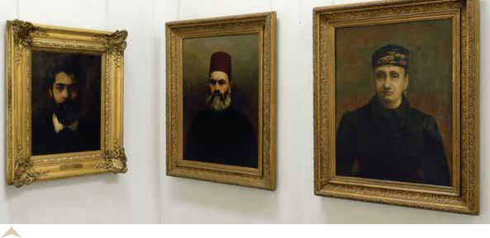

On the left is the self-portrait of one of the most significant Jewish painters in Serbia, Leon Koen (1859 – 1934); to the right are portraits of the Belgrade rabbi from the 19th century, David Mose Alkalaj, and his wife, painted by the Serbian painter Milan Jovanovic.

16 | THE JEWISH HISTORICAL MUSEUM

We now return to history and documentary exhibits.

A very significant moment in the social history of Jews in for-mer Yugoslavia is certainly the es-tablishment of the Federation of Jewish Religious Communities of the Kingdom of Serbs, Croats and Slovens, in 1919. Although very complex in its structure, the Feder-ation from the very beginning proved to be a well organized eth-nic and religious organization, with
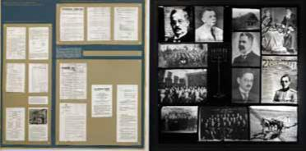
clear and worthy social and cultural objectives and programs. When the Kingdom of Yugoslavia was es-tablished in 1929, a law was also adopted on the religious community of Jews in the Kingdom, and for the federation this meant additional progress and clear identification of its status. The presented copies of documents regarding the Federation of Jewish Communities from that period are only an indication of its numerous and successful activities in the areas of education, publishing, preserving the Jewish identity, and cooperation with European and international Jewish organizations.

As we continue, on the next panel, are photographs of the first President of the Federation of Jewish Reli-gious Communities of the Kingdom of Yugoslavia, Dr Hugo Spicer (President of the Federation until 1933), the second President Dr Fridrih Pops (from 1933 to 1948), and a photograph from a session of the Federation. Along with these photographs, there are photographs dedicated to the strong Zionist movement in the King-dom of Yugoslavia: presidents of the Zionist Council, Dr David Alkalaj and Dr Aleksandar Liht, sessions and meetings of Zionists; a letter by Milan Vesnic, a Serbian envoy to Paris, sent to Dr David Albala, the Serbian envoy in the war mission in the USA, in 1917, in which Vesnic expresses unequivocal support to the Zionist idea and the foundation of the state of Israel. There is also a photograph of Jehuda Haj Alkalaj (1798 – 1878) with wife Ester, the rabbi who is perceived as the predecessor of the Zionist movement in the Kingdom.

A separate thematic unit is made up of copies of documents and portraits of people who have in dif-ferent ways and in different periods made their contribu-tion to the culture in the territory of the former Yugoslavia: Salom Salem, rabbi of Belgrade in the 17th century (born in Edirne, later moved to Amsterdam); Amatus Lusitanus, a doctor from Portugal, who lived in Dubrovnik in the 16th century; Isak Haim Salom, a doctor and representative of the Jews in Sarajevo in mid 19th century; Javer Baruh from Sarajevo, a representative in the Constantinople Parlia-ment, 19th century; Hajim Davico, a writer and consul of Serbia in Trieste, Munich and Thessalonica, 19th – 20th century; Abraham Kapon, writer and translator, founder of the first Jewish newspaper in Bosnia “La Alborada” 19th
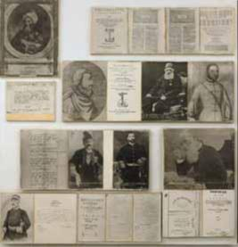
– 20th century; Josif Slezinger, manager and conductor of the Court Orchestra in Serbia, 19th century.

The Federation of Jewish Communities of Serbia | 17
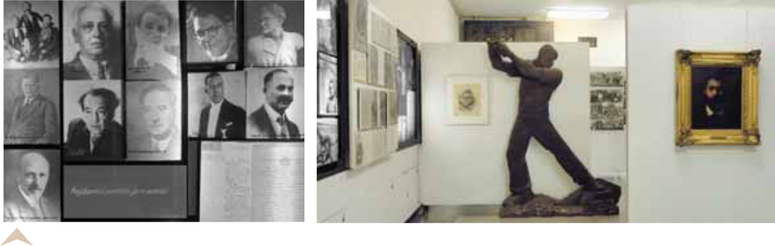

On the left – Jewish artists – actors, conductors, musicians, writers and publishers, in the pe-riod between the two world wars.

On the right, a self-portrait by Mose Pijade, painter and politician, who was President of the Assem-bly of the Socialist Yugoslavia after World War Two; next to it is an interesting wooden sculpture by Slavko Bril “Worker”, a symbol of a socialist art style.

The social, political, art and cultural life of Jews during the first half of the 20th century (un-til World War two), was very strongly developed in all territories of former Yugoslavia. Within the educational and school system, in some major towns, there were Jewish primary schools, and al-so pre-school institutions. Cultural-art associations and societies, such as the Serbian - Jewish Signing Society or the Sarajevo “Lira”, choirs and orchestras, were numerous and enjoyed good reputation among their audiences. Sport societies in Sarajevo gathered many young people, both young men and women engaged in sports. Of special significance in the life of young Jews were the different youth societies – workers and students ones, with their many activities and opti-mism. The activities of Jewish youth societies were based mostly on the Zionist ideas and the no-ble desire to establish the state of Israel, by peaceful means and through hard work. The most popular and the most numerous youth society in the then Kingdom of Yugoslavia was the Ha-somer Hacair.

To the right, Jewish primary schools with their pupils and teachers in Sarajevo, Zagreb, Zemun, Novi Sad; Jewish pre-schools in Bitolj and Sarajevo; Estira Ruso, teacher of the Jewish primary school in Belgrade, with a reputation of great education and entrepreneurship; Jewish trade schools.
To the left, the Jewish cultural and art signing societies in Belgrade, Sarajevo, Zagreb, and other towns, music bands, concerts; Jewish sports societies.
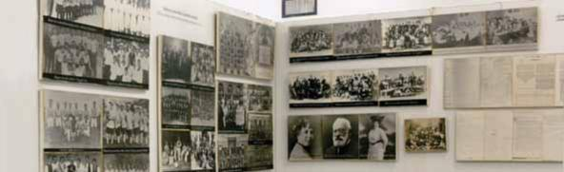

18 | THE JEWISH HISTORICAL MUSEUM
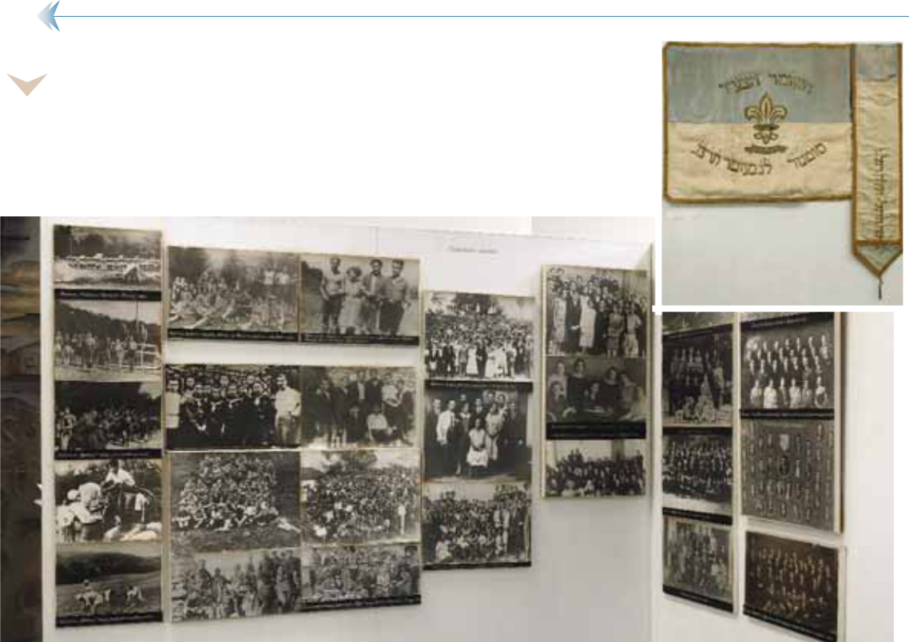

Youth workers’ and students’ societies, their gatherings and events, picnic and working camp activities (hahshare – training in farm-ing and crafts as preparation for Israel and staying in moshav – youth camps).

The original flag of the
most popular Jewish youth
society of the Kingdom of
Yugoslavia, Hasomer Ha-
cair, its branch in Sombor

Almost without noticing it, from joyous photographs showing Jewish youth, pre-war jazz bands, women sports Hazena teams, with ladies wearing now comic clothes, we move on to - wars. In a com-plex, although summarized, collection of photographs we see the participation of Jews in the Balkan wars (the wars Serbia waged against the Turks and Bulgarians for the liberation of the then southern Serbia, later Macedonia) in the period 1912 -1913, and also during the World War One, 1914 – 1918. The World War One was especially tragic for the Serbian people and its army, although Serbia came tri-umphant out of the war. It was exactly this tragic period that resulted in closer links between the Serbs and the Jews who, as citizens of Serbia, although of “the Moses’ religion” (many Jews declared them-selves as “Serbs of Moses’ religion”) demonstrated strong loyalty, dedication and courage. Many Jews were decorated for their contribution by medals of courage and some also received the prize of Karad-jordje’s star, the most prestigious award in this category.

Serbian Jews – soldiers, officers and other participants in the Balkan wars and in the World War One, 1912 – 1918. To the left: a group photo-graph of Belgrade Jews near Edrine (the Second Balkan War against Bulgaria) 1913; Jewish offi-cers on horseback, Benko Davico and Mosa Amar; six individual photographs in a series – David Amar, Isak De Majo, Mosa Pinto, Dr Isak Hercog, Hajim Davico, and Jovan Mandil. In the middle a collection of six photographs: Neti Munk, Binja Daniti, Salom Ruso, Dr Avram josif Vinaver, Dr
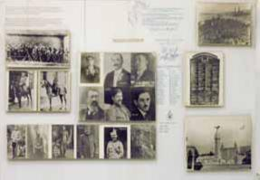

The Federation of Jewish Communities of Serbia | 19

Natan Tajtacak, and Leon Lebl. To the right: copies of photographs: a commemoration of Serbian and Jewish doctors and pharmacists participating in the wars of 1912 – 1918, and a monument to Jewish soldiers in the period 1912 – 1918, located in the active Jewish (Sephardic) cemetery in Belgrade.

After the end of World War One, the Kingdom of Serbs, Croats and Slovenes was established and in 1929 it became the Kingdom of Yugoslavia. The Kingdom strived to develop the economy and ensure peace. However, a period of peace in this part of the world was not equaled by peace elsewhere in the world. Great economic crises of the 1930’s and the increase of anti-Semitism and all forms of xenopho-bia and chauvinism, resulted in the growth of Nazism and the Hitler coming to power in Germany in 1933. While the Nazi ideology was becoming a huge threat to the world, certain social groups in Yu-goslavia, mostly workers and the educated youth, dissatisfied with the politics of the Kingdom and the manipulation of the people, turned towards communist ideologies. The basically humane, noble and protective idea of communism attracted increasing numbers of people, among them a relatively high number of Yugoslav Jews.
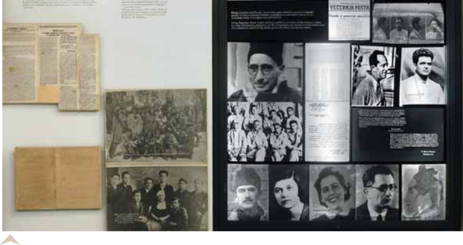

The left panel shows group photographs of young Jews in the period between the two wars, who were to join the Partisan movement in 1941. Up, the youth of Hashomer Hazair in Belgrade; down: the Jewish workers’ society “Matatja”.

The panel to the right, Jewish intellectuals, communists, and those tries as political opponents. Mose Pijade in prison in 1934; up to the right, Haim and Leon
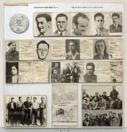
Samokovlija, photographs for police records; down to the left: a group photograph of Jewish political prisoners; to the right, individ-ual photographs of Pavle Bihalji and Rafael Batani; down; individual photographs of Dida De Majo, Olga Alkalaj, Magda Boskovic, Dr Adolf Singer, and a portrait drawing of Pavle Verthajm.

A collection of photographs and copies of documents dedicat-ed to Yugoslav Jews, communists and participants in the Spanish Civ-il War, 1936 – 1939.

20 THE JEWISH HISTORICAL MUSEUM

Copies of articles and documents from the time before the World War Two. Newspaper articles of pre-war publications of the “Jew” (“Zidov” the Jewish newspa-per printed in Zagreb) about the Hitler’s coming to power, about the persecution of Jews in Europe, the barbarian at-tacks against the Jewish com-munity in a Polish town, burn-ing of books which are a “threat to racial purity” of the German people; two anti-Jew-ish decrees published in the Official gazette of the King-dom of Yugoslavia in 1940, and the declaration of the Federation of Jewish Religious Communities of the Kingdom of Yugoslavia, published on the occasion of the anti-Jew-
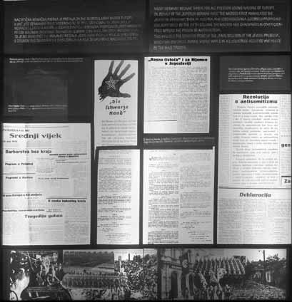
ish decrees, also from 1940.

The Government of the Kingdom of Yugoslavia signed the pact with the Axis powers on 25 March 1941. This resulted in the military coup and the toppling of the Government.

For Yugoslavia, World War Two started with the barbarian German bombing of Belgrade on 6 April 1941, without the war being declared. After 12 days, the Army of the Kingdom of Yugoslavia surren-dered and Yugoslavia was divided between the occupying forces.

Germany established its occupation administration in Serbia, including the region of Banat, and eastern Vojvodina (Vojvodina is northern part of Serbia), and it annexed a part of Slovenia. Italy an-nexed and controlled another part of Slovenia, the Gorski Kotar region and Dalmatia (coastal part of Croatia) and Montenegro. Parts of Kosovo and Metohia, Macedonia and Montenegro were parts of the Italian protectorate “Great Albania”. Hungary annexed Backa (western part of Vojvodina), Baranja and Prekomurje and occupied Medjumurje (regions in Croatia). Bulgaria annexed a major part of Macedo-nia and parts of eastern and southern Serbia. In areas with a significant portion of German (Banat) and Albanian (Kosovo and Metohia) ethnic minorities, their political and occupying forces had actual pow-er. In Croatia, Bosnia and Herzegovina, as well as in Srem (south-western region of Vojvodina) a Us-tasha (Nazi) state was established under the name of “Independent State of Croatia / NDH”.

Among the peoples of the occupied and divided Yugoslavia, the most difficult position was that of Serbs and Slovenes, while members of ethnic and religious minorities – Jews and the Roma were al-most completely destroyed.

The Federation of Jewish Communities of Serbia | 21
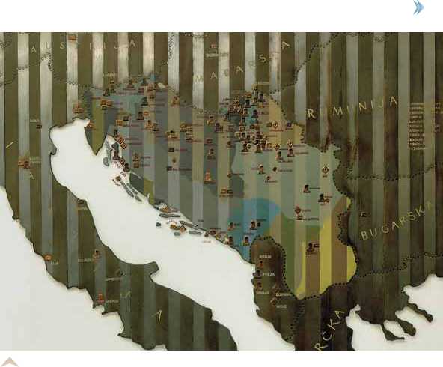

The map of Yugoslavia with occupation zones and marks of death camps. Collection camps, concentration camps, prisons and mass murder sites.

Serbia was occupied by the Germans, who put an end to any protest by means of fierce crimes

against the civilian population. Arrests, executions, hanging followed. Serbia was the only occupied

country in Europe in which the Germans put in practice the rule “100 for one” – for one killed German

one hundred civilians were executed. However, the ones who were to face total extermination were the

Jews. This specific, total genocide
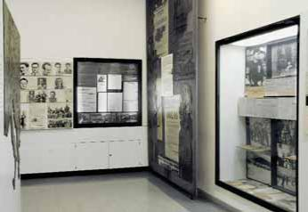
against the Jews, the Holocaust, was

carried out so systematically, so pedan-

tically, that the German military com-

manders, after only several months of

occupation, sent a message to Berlin

that Belgrade was “free of Jews”. And

truly, about 10,000 Belgrade Jews have

perished, and about 85% of all the Jews

living in Serbia had perished. There

were German camps in Belgrade itself,

as well as in other towns in Serbia,

there were mass executions, mass plun-

dering of property ... the Holocaust.

22 THE JEWISH HISTORICAL MUSEUM
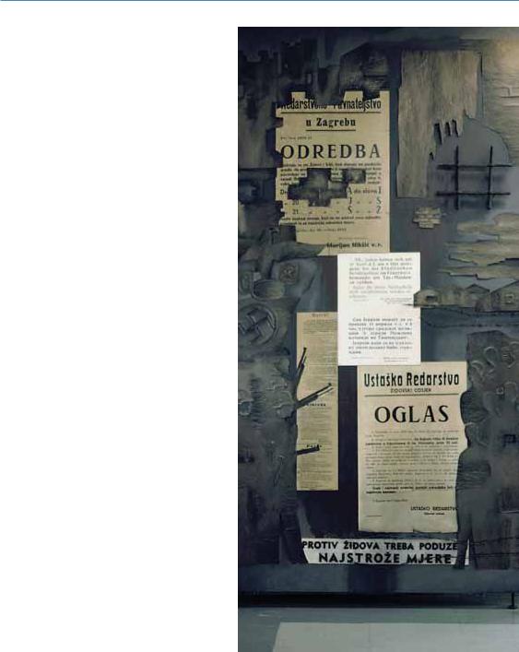

Copies of German and Ustasha anti-Jewish orders, 1941.
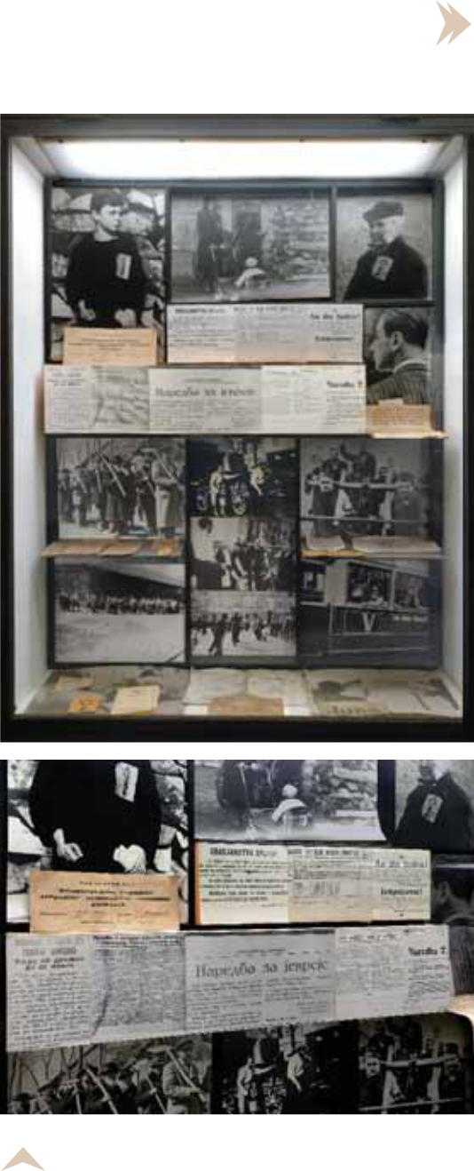

Copies and originals of German, Ustasha, Bulgarian, and Italian anti-Jewish orders, yellow stripes and badges and a number of Jewish ID’s, all used to identify the Jewish population; up: photo-graphs of Jews wearing yellow stripes in Zagreb; down: photographs of Jews undergoing forced labor in Belgrade and in the region of Banat; down, right: photographs of abuse of Jews in Banat by mem-bers of the Volks-Deutscher community, many of whom cooperated with the Germans and took part in crimes committed against the Jews and others.

The Federation of Jewish Communities of Serbia | 23
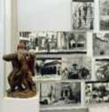

Examples of looting of Jewish property by the Germans and the Ustashas

– the destruction and pulling down of synagogues and Jewish cemeteries in Serbia (Belgrade, Novi Sad, Senta, Stari Becej), Croatia (Zagreb, Vukovar, Sisak, Osijek), Bosnia (Sarajevo). In front of the panel, the sculpture “The Inmates” by sculptor Vesna Skopal; to the right are graphics and models of the monument to Jewish victims (the original is in Yad Vashem) by one of the most famous Jewish artists, Nandor Glid.

Up: photographs of deportation of 7,160 Macedonian Jews to the Treblinka death camp and copies of documents – the German-Bulgarian agreement on deportation of Macedonian Jews (right) and a cable of the German camp administration confirming their arrival in Treblinka (left).

In the middle a collage of documents: fragments of different German reports regarding the situation in Belgrade, the Sajmiste concentration camp, the execution of Jews in 1941 (a transcript in the Serbian lan-guage from 1948); Ustasha ads regarding the arrests of Jews (Dubrovnik, 1941, Ustasha orders for forced migration of Serbs and Jews (Zagreb, 1941), Ustasha reports regarding the detention of Jews in camps and other anti-Jewish actions.
Down: series of photographs of German, Hungarian and Ustasha crimes – physical torture, hang-ing of individuals and mass hanging of hostages in Subotica, deportation to the Sajmiste death camp, search and looting, mass executions in Sabac, the scenes of the so-called “Raid” in Novi Sad, one of the most horrible crimes by Hungarian fascists against civilians, 1942.
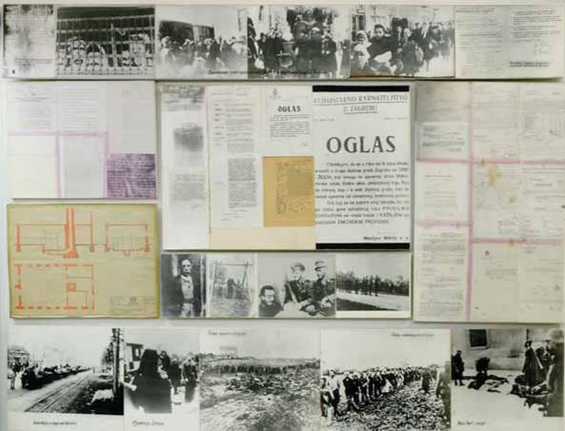

24 THE JEWISH HISTORICAL MUSEUM
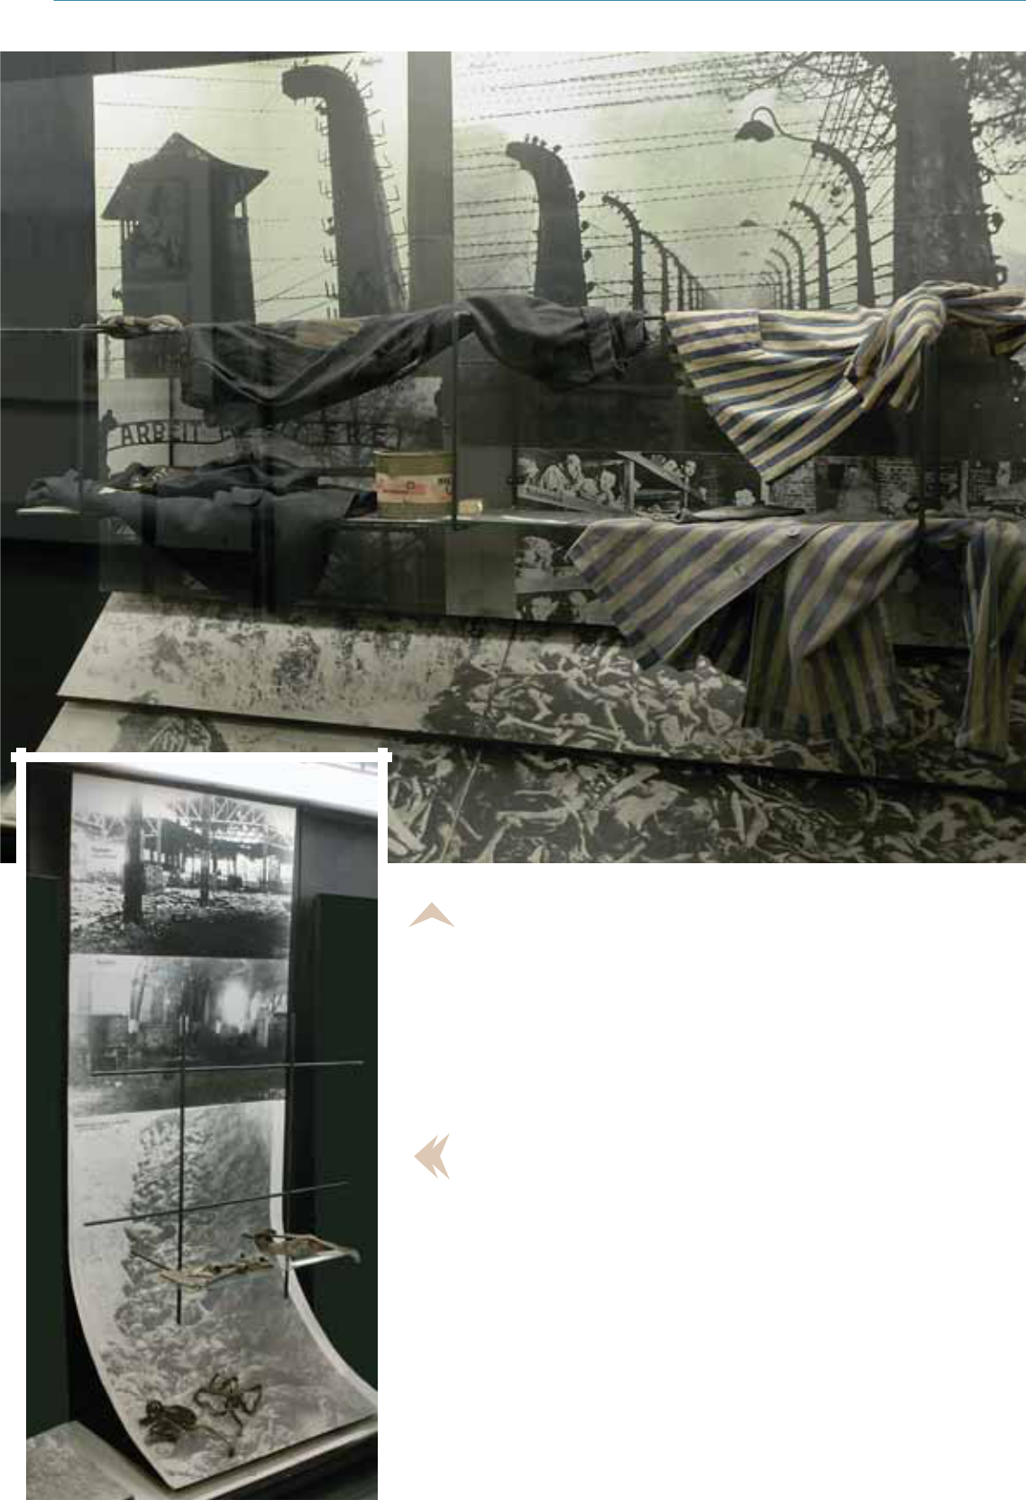

Photographs of Auschwitz, Buchenwald, and the bod-ily remains of victims in mass graves; original clothing of inmates, soap made of human corpses and cans with poi-

sonous gas Cyclone B.

Photographs of the Sajmiste camp (after the bombing of Belgrade in 1944) and bodily remains of victims in mass graves. The Sajmiste camp was the biggest Nazi camp in the Balkans, intended primarily for Jewish women and chil-dren from Belgrade and Banat, while the number of men was lower. Jewish men from Belgrade and Banat were sent to the camp “Topovske supe”, from where they were transported in trucks to be executed outside Belgrade. Aside from a big number of inmates from the Sajmiste camp who dies of hunger and illnesses, Jews from the camp were executed by the use of a special purpose hermetically tight truck from Berlin -Sauer, in Serbian called “dusegupka” in which people

The Federation of Jewish Communities of Serbia | 25

were suffocated while being transported from Sajmiste to the village Jajinci in the vicinity of Belgrade. In Jajinci, the bodies were unloaded and dumped into mass graves. From mid December 1941 to May 1942, the Germans in this manner executed all Jews from the Sajmiste camp. After that time, the camp changed its purpose – it was used for the detention of primarily Serbs and partisans, from where many were deported further to other camps outside Yugoslavia.

Right: photographs of the German concentration camp for Serbs and Jews in Banjica (Belgrade), from which inmates were taken outside of the city for execution.
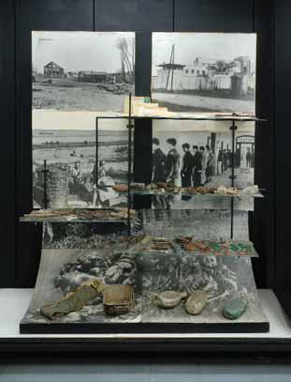
Left: photographs and original camp post-cards (in the middle) from the Ustasha camp Jasenovac in Croatia – the biggest non-Ger-man camp in Europe used for the extermina-tion of Serbs, Jews and the Roma, as well as political opponents, within the Ustasha idea of creating an ethnically cleansed Croatia. In the complex of the Jasenovac camp, the Us-tashas executed tens of thousands of people, in the most savage manner – beating them by hamers and using knives…

In front of these photographs are exhibits in form of original personal belongings of the murdered Jews from Backa, who were in-mates in the Bor mines for forced labor in 1944. These belongings were found while ex-cavating the mass grave near Crvenka, where near the end of the war the Germans per-formed a mass murder of those inmates.

Right: photographs of Ustasha camps in Djakovo and Sisak (children’s’ camp); Italian camps Rab and Feramonte; German camps Sajmiste, Belgrade, and the “Red cross” Nis.

Left: examples of the Holocaust in Europe: the Warsaw ghetto, Majdanek, Vobelin, Dahau, Belzen, Treblinka, Nordhausen. In front is a model made of marble of the Monument of the Jewish Victims in Bor, by sculptor Momcilo Krkovic.
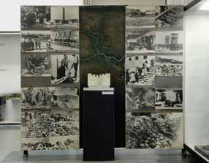

A great number of Yugoslav Jews affiliated with the Communist Party which, during World War Two demonstrated an enviable level of or-ganization in all forms of struggle against Nazism, the German occupiers and their allies and collaborators. Many Jews, communists, di-rectly of indirectly, took part in the resistance Movement and about 4,500 of them joined the

26 | THE JEWISH HISTORICAL MUSEUM

Partisans. Although partisans consisted mostly of poorly armed citizens and farmers, in relation to whom the Germans did not have any kind of war morale, they soon grew into a true army, with strong discipline and excellent capabilities, especially in guerilla warfare.
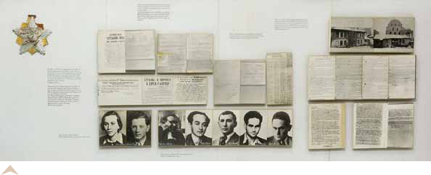

Copies of documents – different reports regarding the execution of Jews and other commu-nists in Zagreb, Belgrade, and Sarajevo; photographs of Ruza Sulman and Sandor Frank, executed in Zrenjanin in 1941; continued: photographs of Dr Istvan Gere, Istvan Miler, Spiro Macas, Karolj Levi and Denes Levi, all hanged in Senta in 1941.
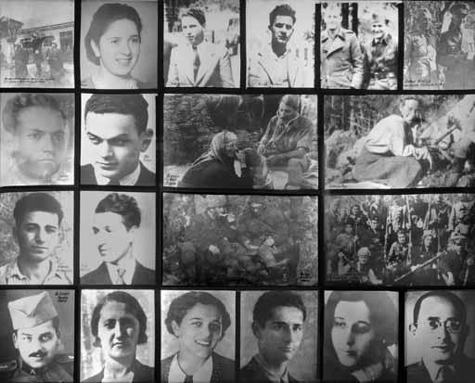

collection of photo-graphs of Jewish partisans,
individuals

and group

scenes

from

World War

Two.

The Federation of Jewish Communities of Serbia | 27

The panel to the left: Josip Broz Tito, the Supreme Commander of the National liberation Army (later the Pres-ident of the SFR Yugoslavia) and Mosa Pijade, member of the Supreme Head-Quarters (later President of the National Assembly, a much appreciated and reputable public official), photographed in 1942 in Jajce; below the Rab Battalion – founded by Jewish interns in the Italian camp on the island
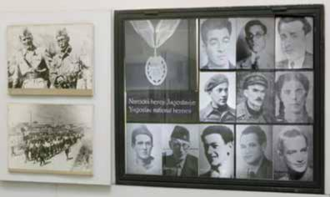
of Rab, after the capitulation of Italy in 1943. The battalion soon joined bigger Partisan formations.

The panel to the right: Yugoslav Jews, national heroes.

About 650 Jews, who were officers of the Yugoslav Royal Army, were arrested and deported to military camps in Germany. Although the position of Jews was much worse that that of other military prisoners, the fact that they were members of the official army of the Kingdom of Yugoslavia made the Germans to at least partially respect the Geneva Convention. Although their life was always in danger and hanging by a thread for the smallest act (some were killed or dies under different circumstances), most Yugoslav Jewish prison-ers still managed to return and be part of the general reconstruction of the devastated country.

A group photograph of Jews, military prisoners in Osnabruck, Of-lag VI C, 1942; a photography of Ћenja Kozinski from Belgrade, who was killed in 1944 in the military camp due to anti-Nazi activism.
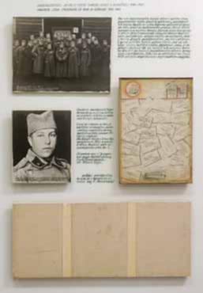

After the end of World War Two and the liberation of the whole country, the Jewish community or precise-ly the Federation of Jewish Communities of Yugoslavia began to revive. It is estimated that in the former Yu-goslavia 82% of the total Jewish population had per-ished during the Holocaust. Whole families had per-ished, even whole Jewish communities, meaning that of the total of 82,000 Jews which was the number in the former Yugoslavia before the beginning of World War Two (including Jewish refugees from a number of European countries), about 67,000 had been killed. Ir-respective of this tragic balance, the Federation of Jew-ish Communities of Yugoslavia consolidated itself once again and gathered together the surviving Jewish com-munities. Life went on …

28 THE JEWISH HISTORICAL MUSEUM
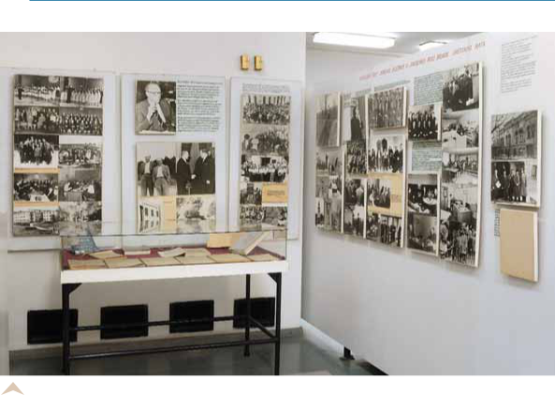

A photograph of the building of the federation of Jewish Communities of Serbia in Zmaj Jov-ina Street (in 1948 the federation moved to the building of the Jewish Community of Belgrade in Kral-ja Petra Street 71c); a group photograph with Dr Fridrih Pops, who was President of the federation from 1933 to 1948; photographs of different social institutions of the Federation in charge of assisting those in need; the development and restoration of different activities (members of the so-called Autonomous Aid Board, the rehabilitation of the remaining Ashkenasi synagogue in Belgrade and religious services, sessions, Monument to Jewish victims in the Sephardic cemetery by architect Bogdan Bogdanovic, from 1952); photographs of Aliyas of Yugoslav Jews to Israel, in the period 1948 - 1952; Presidents of the Federation, Dr Albert Vajs, 1948 – 1964, and Dr Lavoslav Kadelburg, 1965 – 1991.

The Federation of Jewish Communities of Serbia | 29

Museum Collections and the Archives
The Jewish Historical Museum in Belgrade consists of two basic units: museum collections and archives.

Museum collections:

ART – PAINTING COLLECTION – paintings, drawings and sculptures.

Time and territorial framework: 19 – 20 century - former Yugoslavia, Europe, the USA, Is-rael.

CULTURAL - HISTORICAL COLLECTION

- Collection of medals, badges, plaques and flags.

Time and territorial framework – 20 century - former Yugoslavia, Europe, Israel.

- Collection of rare and valuable books,

Torahs, Hagada, prayer books, manuscripts, notebooks, religious books.

Time and territorial framework – 18 – 20 century – Belgrade, former Yugoslavia, Europe. HISTORICAL COLLECTION – The Holocaust collection

- Artifacts from camps, personal belongings of victims, found in mass graves during excava-tions and yellow strips and badges used to identify the Jewish population.
- Partisan military equipment and weapons.

Time and territorial framework – 20 century – former Yugoslavia, Germany.

ARCHAEOLOGICAL COLLECTION

- Artifacts, tombstones, plates from facades of synagogues.

Time and territorial framework – 6 and 7 century BC, Egypt, Palestine, Iraq; 17 – 20 centu-ry, Serbia.

JUDAICA COLLECTION – us a highly specific ethnological collection with elements of ap-plied arts, including: synagogue ritual objects, household and personal objects and amulets, marriage contracts – ketubah, clothes and jewelry. A separate group within the collection con-sists of objects that were used in Jewish families and had a practical, daily significance, and at the same time were a part of the tradition.

Time and territorial framework – 17 – 20 century – Serbia, former Yugoslavia, Europe, Is-rael, North Africa.

The Archives of the Jewish Historical Museum:

The Jewish Historical Museum has a relatively rich archives consisting of about 1000 meters

30 THE JEWISH HISTORICAL MUSEUM

in length of material. The archives include material related tot he life and work of the Federation and individual communities of former Yugoslavia from the time before the World War two, Jewish pre-war press, materials related to anti-Semitism and the Holocaust, and a wealth of materials related tot he Federation and Jewish communities in the period since 1945, as well as chemerotheca. Apart from doc-umentation and photo-documentation, the archives include two data bases – of victims of the Holo-caust from the whole territory of former Yugoslavia and the Jewish registry books of Belgrade.

Having in its possession this kind of archives implies that the Jewish Historical Museum has an on-going and very dynamic cooperation with numerous researchers of different professional profiles, na-tionally and internationally. The Museum also cooperates with national and international museums and provides different forms of information, exchanges publication and photographs, participates in exhibitions organized and staged by other museums, and in some cases copies of exhibits owned by our Museum are exhibited in standings exhibitions in international museums, (Memorial Holocaust Muse-um in Washington, Memorial to the Murdered Jews of Europe in Berlin, etc.).

One of the key tasks within the archive activities in the Museum since 1998 was intensive search and collection of data and verification of data concerning Jews victims of the Holocaust. Based on these data, many of the Holocaust survivors exercised their right to compensation from Germany (through the Claims Conference).

The Federation of Jewish Communities of Serbia ₃₁

Exhibitions of the
Jewish Historical Museum

The Jewish Historical Museum has staged numerous thematically diversified exhibitions, of artistic and scholarly nature. It is interesting to note from the number of exhibition that a relatively small museum, such as the Jewish Historical Museum has staged even two exhibi-tions annually, with intermittent exhibitions outside Belgrade. To illustrate the topics covered by our exhibitions we will state here only about 20 titles of exhibitions from different time pe-riods:

- Exhibitions of graphics by Radovan Hirsl, 1971. Belgrade;

- Art processing of metals for Jewish holidays and rituals, 1974. Belgrade;

- The Baruh family – family of revolutionaries, 1976. Pozarevac, Nis;

- Embroidered textiles from Jewish collections in Yugoslavia, 1978. Belgrade;

- Jewish press in Yugoslavia until 1941, 1982. Belgrade;

- Holiday traditions among Yugoslav Jews, 1986. Belgrade;

- Jews in the territory of Yugoslavia (in cooperation with the Museum in Zagreb), held in 1988 in Zagreb, in 1989 in Belgrade, and in 1990 in New York (USA) and in Toronto, Canada
- Two simultaneous exhibitions:
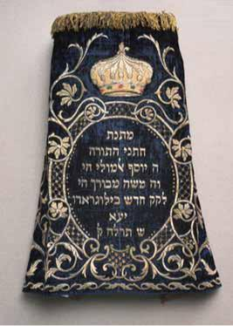
Sephardic literature, publications and writing in Yugoslavia, and

The Jews of Bitolj in photographs by Milton Manaki,

Staged on the occasion of the big event Sepharad 92 in the Cultural Centre of Belgrade in 1992.

- The Rab camp, on the occasion of the 50th anniversary of capitulation of Italy and the liber-ation of the camp, 1993. Belgrade;

- The laces of my aunt Erna, exhibition of paintings by Mirjana Dragic – Lehner, academic painter, 1993. Belgrade;
- Geca Kon – bookshop keeper and pub-lisher, 1994. Belgrade;

- Jewish youth societies in Yugoslavia 1919 – 1941, 1995. Belgrade;

- Jews of Dorcol – The story of our neighbors who are no more, staged in Rex, Belgrade, 1997, and had a visiting exhibition in Erfurt, Germany, 1998.;
Везене тканине, детаљ

32 | THE JEWISH HISTORICAL MUSEUM
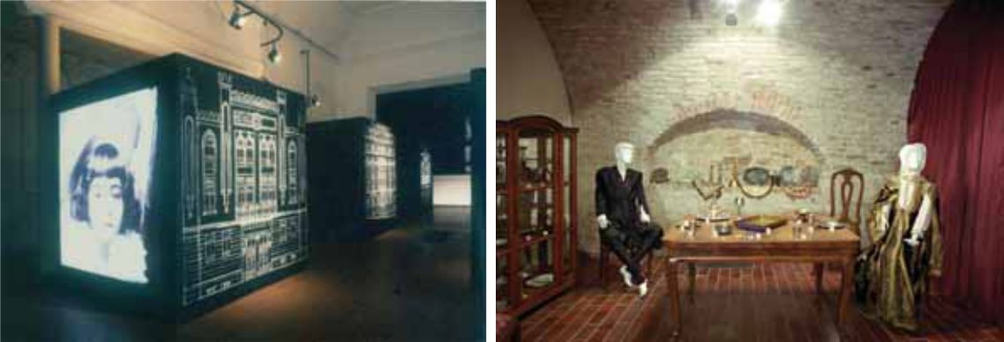

„Прича о комшијама којих више нема“ “Животни циклус - обичаји код Јевреја”

(детаљ) (детаљ)

- Jewish Customs - The Life Cycle -, staged in the Castle of Princess Ljubica, Belgrade, 1998, on the occasion of 50 years of the Jewish Historical Museum;

- Kladovo – Transport, a European story, Kladovo - Belgrade – Kragujevac,

2002 – 2003, the exhibition was staged within the international event Kladovo – Transport in 2002, organized by the Museum.

- From prisoner camps, exhibition of drawings and aquarelle paintings by Mose Mevorah and Ra-jko Levi; staged in the Multi-Cultural Centre in Belgrade in 2003, on the occasion of the European Days of Jewish Culture.

- Sephardic Heritage in the Balkans, exhibition staged within the event Esperansa 2004, in the Cervantes Institute, Belgrade, 2004.

- Documents of Philatelica Judaica I, Belgrade, 2006.

- A series of three art exhibitions – Albert Alkalaj, Dida Demajo, Bora Baruh and Rajko Levi, in the Cervantes Institute, 2006 – 2007.

- Hagada – from illustration to illumination, the Faculty of Philology, University of Belgrade, Belgrade 2008.

- Documents of Philatelica Judaica II, Belgrade 2008.

- The Federation of Jewish Communities 1919 – 2009, from the times of the Kingdom of Serbs, Croats and Slovenes to the Republic of Serbia, center for Culture Municipality Stari Grad, Belgrade 2010.
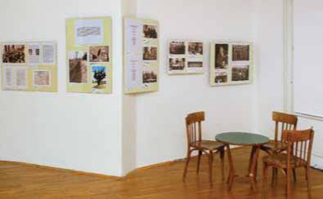

„Савез јеврејских општина 1919 – 2009“ (детаљ)

The Federation of Jewish Communities of Serbia | 33

The publishing activity of the Jewish Historical Museum

Since the year 1971 the Museum has been publishing the Compendium of the Jewish His-torical Museum. The Compendium is a periodical publication and consists of technical and scien-tific articles and archive materials relevant to the history of Jews in the Balkans, as well as themat-ically relevant memoirs. A total of 9 such Compendiums of the Jewish Historical Museums have been published to date. The first 6 publications were dedicated to specific themes: Jews of Dubrovnik (Volume 1, 1971), The Participation of Jews in the National Liberation War (Volumes 2-3, 1973-1975), Jews of Yugoslavia (Volume 4, 1979), Jews of Subotica (Volume 5, 1987), and Jews of Belgrade (Volume 6, 1992). The preparation of the subsequent volumes was not so strictly the-matically limited, so Volume 7 (1997), Volume 8 (2003) and Volume 9 (2009) contained articles on different topics, and this approach is to be used in the future as well.
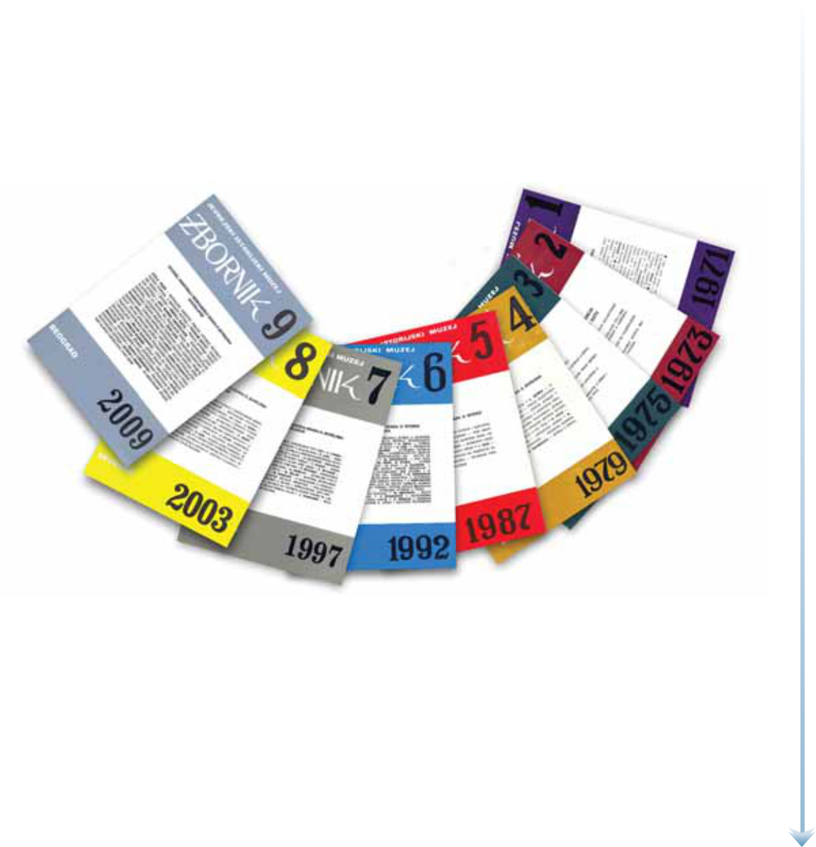

Along with study exhibitions (exhibitions of textiles, books, newspapers, holiday traditions, lifecycle traditions, youth societies, documentary materials, etc.) catalogues, monographies with catalogues and CDs, 2 so far, were also published. The most impressive publications of the Muse-um – monographies with catalogues accompanying the exhibitions with the same title are the fol-lowing:

- Embroidered textiles from Jewish collections in Yugoslavia, 1978. Belgrade;

- Jewish press in Yugoslavia until 1941, 1982. Belgrade;

- Holiday traditions among Yugoslav Jews, 1986. Belgrade;

34 | THE JEWISH HISTORICAL MUSEUM

- Geca Kon – bookshop keeper and publisher, 1994. Belgrade;

- Jewish youth societies in Yugoslavia 1919 – 1941, 1995, Belgrade, bilingual publication in Serbian and English;

- Jews of Dorcol – The story of our neighbors who are no more, 1997. Belgrade, 1997, pub-lication in three languages, Serbian-English-German;

- Jewish Customs – The Life Cycle - Jewish traditions, 1998 Belgrade and in 1999 a CD under the same title, bilingual publication, Serbian-English;

- Documents of Philatelica Judaica II, 2008. Belgrade, bilingual publication, Serbian-English. For this publication, the Jewish Historical Museum won the bronze medal at the International Philate-

listic exhibition in Montenegro in 2009, in the category of philatelist literature.
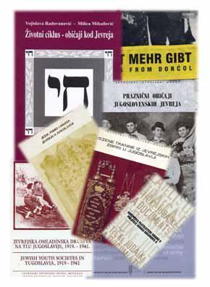

translated and published in English. There are plans to translate the re-maining thee volumes. The main sponsor for this edition was Haim – Mile Pinkas from Carakas.

In the modern world of high technology, the website is one of the forms of publishing activity of the Museum. A new, excellently de-signed wcb site of the Jewish his-torical museum can be visited at the following address:

In terms of special publications we shall mention here the Catalogue and Compendium of discussions presented at the sci-entific conference The Menorahs from Celarevo, Belgrade 1980 – 1983; publications on the topic of the culture of Sephardic Jews including Sephardic Jews in South-Slavic countries, Belgrade 1992, bilingual publication, Serbian-Eng-lish, and the books Proverbs and Sayings of Sephardic Jews from Bosnia and Herzegovina, Belgrade 1976, and the book

Proverbs, Sayings, and Short-Stories of Sephardic Jews from Macedonia, Belgrade 1978, both these books are pub-lished in three languages, Serbia-English-Ladino.

The Museum is also the publisher of the edition of spe-cial significance titles We Have Survived… Jews about the Holocaust, collections of authentic testimonies of Jews of former Yugoslavia on how they managed to sur-vive the Holocaust. The editorial board of these publica-tions has been working actively, on pro-bono basis, since 1999. Five books have so far been published in Serbia, the first and second volumes have in the meantime been
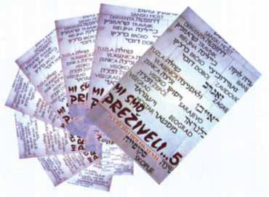

www.jimbeograd.org

The Federation of Jewish Communities of Serbia ₃₅

Special activities
and events organized by the Jewish Historical Museum

Since the Jewish Historical Museum is „unique“ among the museums in Serbia, it has numer-ous regular, daily activities. The Jewish Historical Museum provides all information related to the history, traditions and the culture of the Jewish population in the Balkans, and maintains contact with people of different professions, from scientists to amateurs, secondary school pupils to the-atre costume designers, journalists, and others. This includes also citizens of Belgrade as well as people from other continents. However, apart from its daily activities, exhibitions and its publish-ing activity, we should mention some special activities and events that the Jewish Historical Mu-seum has organized or co-organized.

One of the most noble, multi-annual, special activities of the Museum is activities related tot he Righteous among the Nations. When diplomatic relations between Yugoslavia and Israel were discontinued in 1967, it was necessary to change the procedure whereby these Charters were handed by the Ambassador of Israel. As the Israeli Embassy in Belgrade was closed, all activities related to providing information, receipt and forwarding of proposals for the Righteous, contacts and cooperation with the Yad Vashem, and finally, the ceremony itself, were taken over by the Federation of Jewish Communities of Yugoslavia, and since 1989, this was officially the obligation of the Jewish Historical Museum. Most cases were solved in this manner although from time to time we heard about individual Righteous who, thanks to the Jews whom they saved, went to Is-rael and received their tribute on the spot. This possibility, in form of an organized trip, was pro-vided in 1990-1991, for the Righteous among the Nations from the whole territory of former Yu-goslavia. The journey was funded by the Jewish benefactor, Mr. Harvey Sarner, and the trip was organized by the federation via the Museum. This cooperation which lasted for several months was excellent and it resulted in a seven-day visit by a group of the Righteous among the Nations in April 1991 to Israel with all the respect that such people deserve.

Several months after that time, the disintegration of former Yugoslavia began, and with it a key change in the organization of the Federation of Jewish Communities. Still, the activities re-garding the Righteous among the Nations were not finalized, but were only divided according to territorial competences.

Although under such circumstances the rules of procedure for the award of the Righteous among the Nations, we can conclude that the Federation of Jewish Communities of Yugoslavia (subsequently of Serbia), together with its Jewish Historical Museum, organized very ceremonious

36 THE JEWISH HISTORICAL MUSEUM

and excellent events for the award of medals and certificates to the Righteous among the Nations from our country. The medals and certificates are made by the Yad Vashem and sent to Belgrade and hand-ed to the Righteous among the Nations by the President of the Federation. In terms of care in prepara-tions, organization, the number of invitees and the tone of the ceremony, these events were in no way less ceremonious than those organized by embassies.

Finally, in 1997, the Embassy of Israel to Belgrade was re-opened, and the tasks related to the or-ganization and handing of medals to the Righteous among the Nations was taken over by the Embassy.

In 1492 Jews were expelled from the Iberian Peninsula. Many Sephardic Jews settled in Serbia and Belgrade. Five centuries later, in 1992 in Belgrade, our Museum with the support of our friends and as-sociates, among them Simha Kabiljo Sutic, a historian of literature, organized an event lasting for a number of days, titled Sefarad 92. The Sephardic “path of tears” was marked in a memorable man-ner: a ceremonious academy including a concert of Sephardic music was held at the concert hall Ko-larac; two exhibitions were staged in the Cultural Centre of Belgrade attracting great media and public interest – Sephardic literature, publishing and writing in Yugoslavia, by author Milica Mi-hailovic, and Jews of Bitolj in photographs by Milton Manaki, by author Vojislava Radovanovic; a scientific gathering was organized on the topic of Sephardic history, literature, and culture and, the publications included the catalogue accompanied with bilingual Serbian-English publication Sephardic Jews in Yugoslav Countries, which still serves the purpose of professional reference book.

Still, the biggest and the most complex among the events organized by the Jewish Historical Muse-um so far was Kladovo – Transport, commemorating the tragedy of Jewish refugees from European countries, in the period from 1939 until their destruction in 1942. A group consisting of more than a thousand Jews from Austria attempted, travelling down the Danube River through Yugoslavia, to arrive to the Black Sea, planning to go via Turkey to Israel (Palestine). The plan failed, and it is sufficient to say that the group could not pass our borders and stayed on the frozen Danube near Kladovo. The sit-uation became increasingly complex until the time when Germany occupied Serbia and there followed a general genocide against the Jewish population. Only a group of children from the Transport survived and this group, after a series of terrible events, finally arrived to present day Israel.

The idea for the execution of this ambitious project which was successfully implemented in October 2002, came from Aleksandar Fredi Mosic, another friend of our Museum. The preparations lasted for several months, and the Museum managed to establish contacts with a group of survivors of the Trans-port and organized for them to visit and a seven day stay in Belgrade. Most of the “children” from the Transport live in Israel, and it was from there that they arrived for this event, except one family who came from Austria. They all brought with them their children, grandchildren, close relatives. A ceremo-ny welcome was organized for them in the building of the Jewish Community of Belgrade. Over the week of their stay in Belgrade, Kladovo, and Sabac commemorations were organized and held for vic-tims of the Transport, and in Kladovo a monument to victims was inaugurated, designed by architect Mimi Bihalji - Vuckovic. Two exhibitions were staged: the exhibition by our museum titled Kladovo – Transport, a European Story, first staged in the Cultural Centre of Kladovo, later in Belgrade and Kragujevac, at request, and it was organized for the Jewish Museum from Vienna with the exhibition Kladovo – Escape to Palestine, which was ceremoniously opened in the National Museum in Bel-grade. Another significant event was the international round table on the topic of the Kladovo Trans-port, with the participation of 15 historians from Serbia, Austria, Germany, Israel, Croatia and the USA.

The Federation of Jewish Communities of Serbia ₃₇

The round table attracted great media interest. The whole event was accompanied by relevant publica-tions, a CD was developed, and shortly after the event a bilingual Compendium of works (Serbian-Eng-lish) of works and discussions from the round table was published.

This significant event was organized by the Jewish Historical Museum under the auspices of the fed-eration of Jewish Communities of Serbia, and support for it was provided by the Embassies of Austria and Germany, the National Fund for Victims of National-Socialism, the Municipality Kladovo, the Na-tional museum Belgrade, the National museum Sabac, Yugoslav Cinema Institute, and the Ministry of Culture of the Republic of Serbia.

